**DAILY ONLINE ACTIVITIES SUMMARY**

|  |  |  |  |  |  |  |  |  |
| --- | --- | --- | --- | --- | --- | --- | --- | --- |
| **Date:** | 23/05/2020 | | | | | **Name:** | D Richard Franklin | |
| **Sem & Sec** | Fourth SEM section A | | | | | **USN:** | 4AL18CS020 | |
| **Online Test Summary** | | | | | | | | |
| **Subject** | | Data Communication | | | | | | |
| **Max. Marks** | | 30 | | **Score** | | | 25 | |
| **Certification Course Summary** | | | | | | | | |
| **Course** | Complete Python Bootcamp : Go from zero to hero in Python 3 | | | | | | | |
| **Certificate Provider** | | | Udemy | | **Duration** | | | 1 Hour 30 minutes |
| **Coding Challenges** | | | | | | | | |
| **Problem Statement:** 1. Triangular numbers  2. Find the product | | | | | | | | |
| **Status:** Completed | | | | | | | | |
| **Uploaded the report in Github** | | | | | YES | | | |
| **If yes Repository name** | | | | | <https://github.com/richard3658/lockdown-coding> | | | |
| **Uploaded the report in slack** | | | | | YES | | | |

**Online Test Details:**

The online test was from module 1 and module 2 which was about the introduction to data communication, about network models, digital transmission, analog transmission and introduction to physical layer. There were 30 questions and the duration was 40 minutes. The questions were optimal and were easy. The score that I got in the test is 25/30.

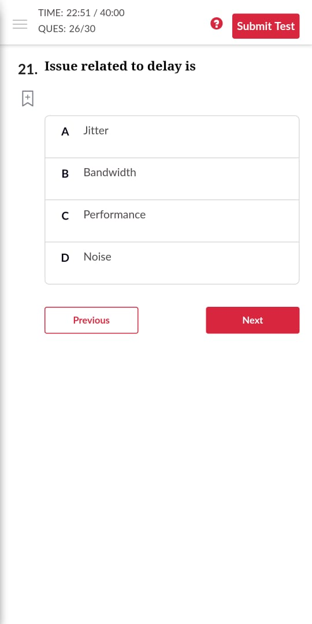 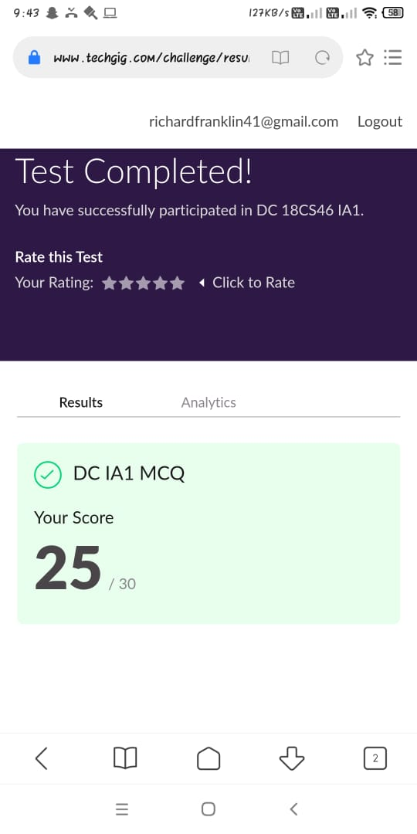

**Certification Course Details:**

**Name of the course**: Complete Python Bootcamp: Go from zero to hero in Python 3

**Certificate Provider**: Udemy

This course has 19 sections and the total duration is 24 hours.

In the fifth day I went through the section which was about exception handling. It was all about different types of exceptions and how to handle them while going with a program.

**Snapshot:**

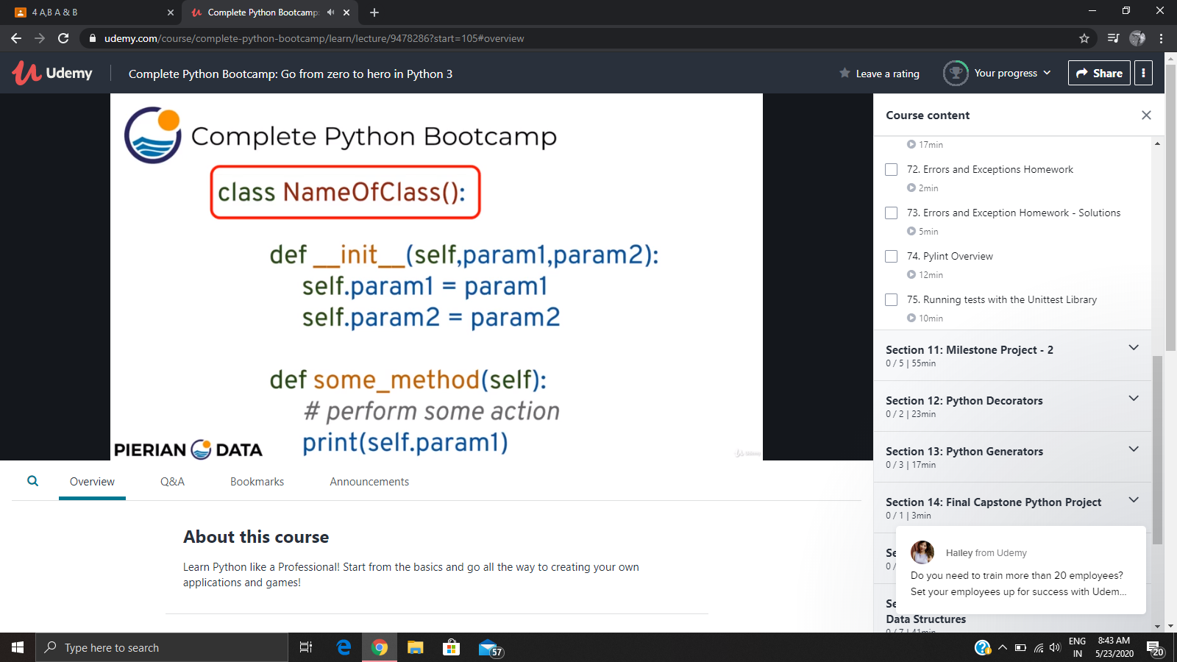

**Online Coding Details:**

Problem 1: (using C language) Write a program to print n triangular numbers.

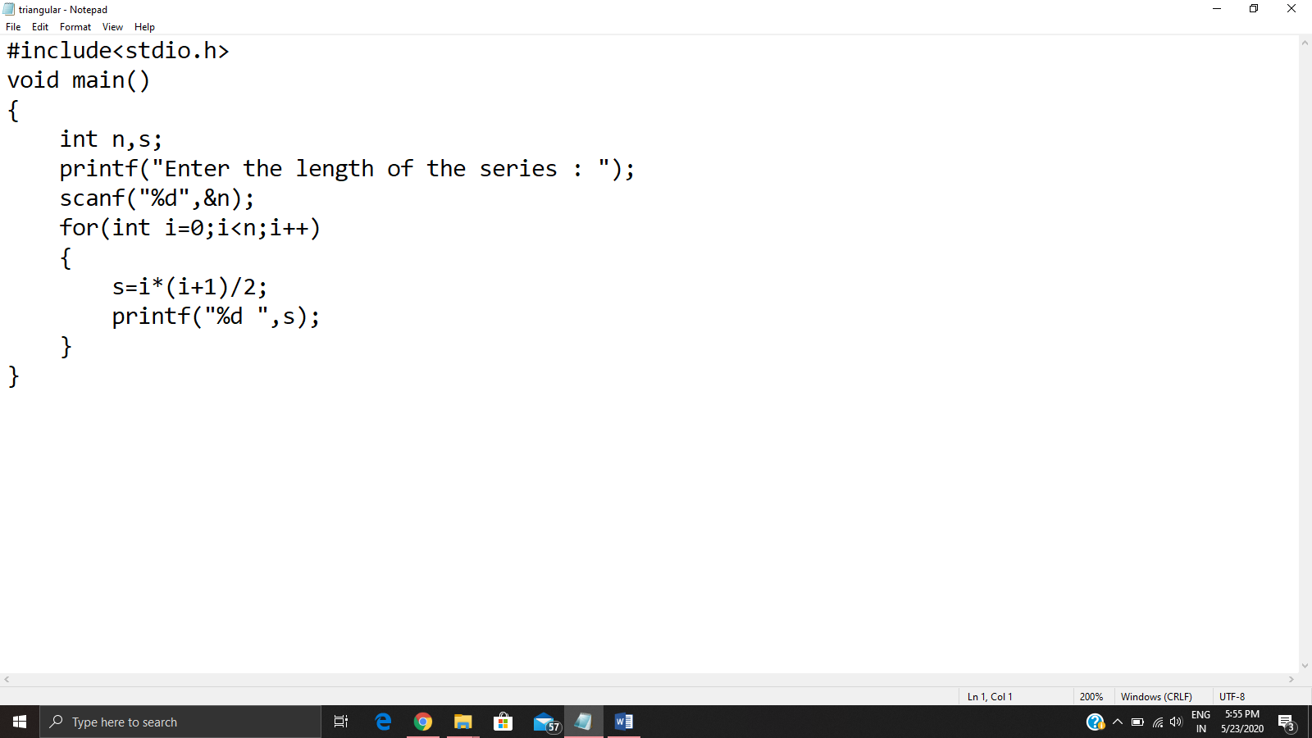

Problem 2: (Using Python) You have been given an array A of size N consisting of positive integers. You need to find and print the product of all the number in this array modulo (10^9)+7

